**Implementing 3 tier architecture**

1. In Asia Pacific (Sydney) region , Create a VPC

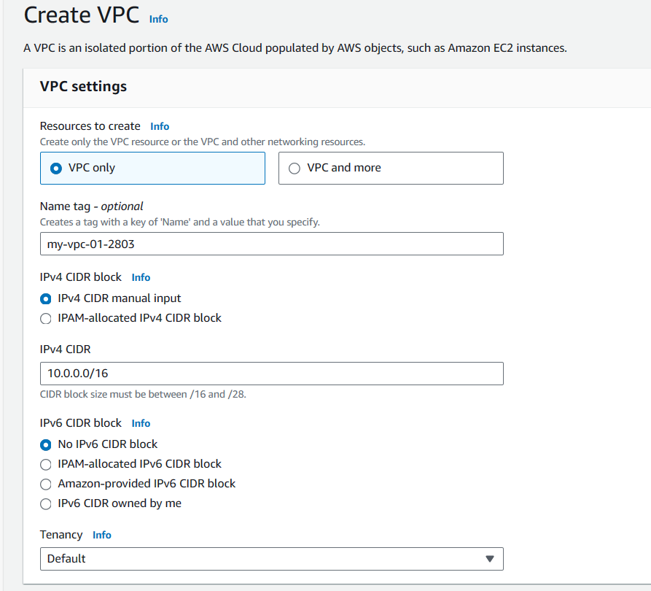

2.Create 1 public subnet and 2 private subnets in ap-southeast-2a availability zone

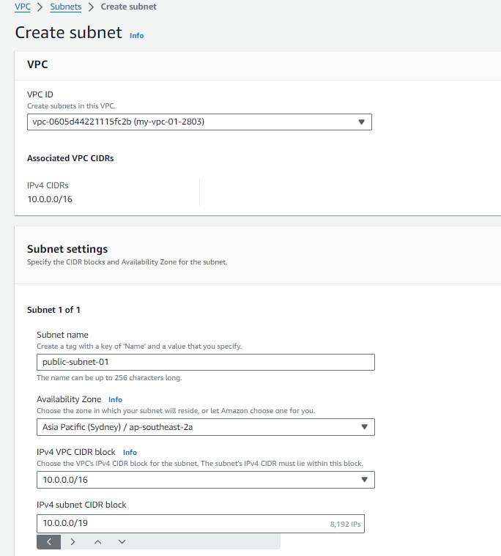

1. Create 1 public subnet and 2 private subnets in ap-southeast-2b availability zone

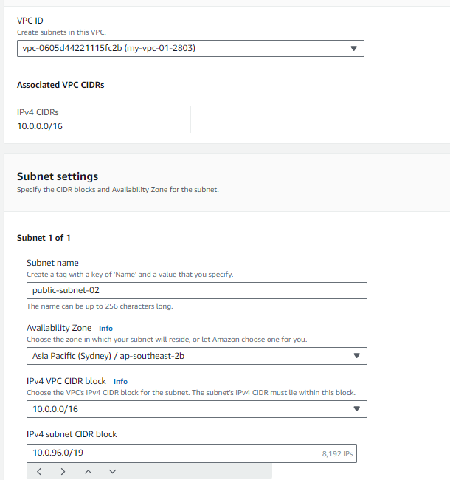

1. Create total 6 subnets in 2 AZ’s ap-southeast-2a and ap-southeast-2b :

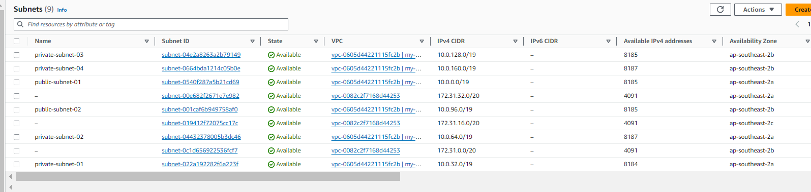

1. Create one route table for each subnet , then total 6 subnets will be created.

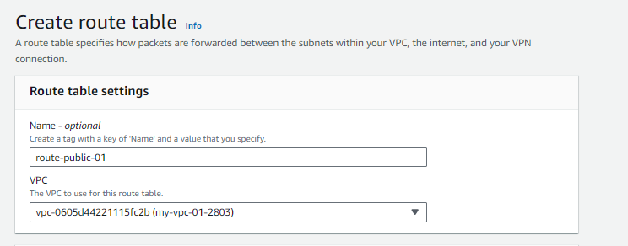

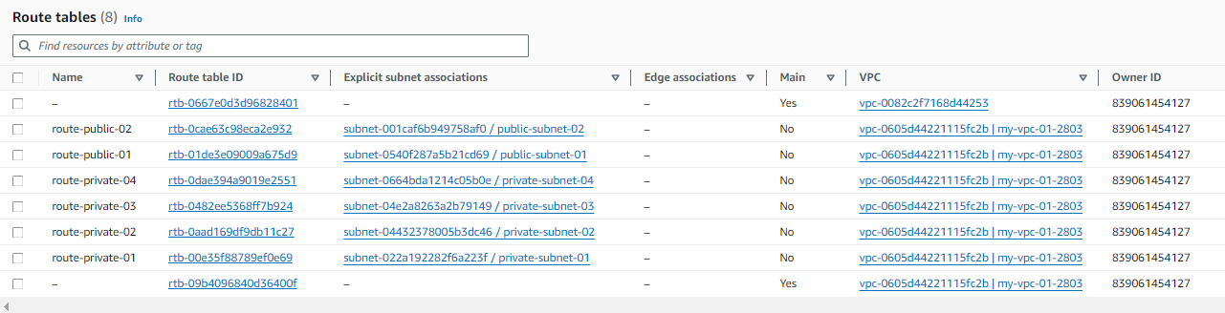

1. Attach route table to subnet Click on subnet associations and click on edit subnet association

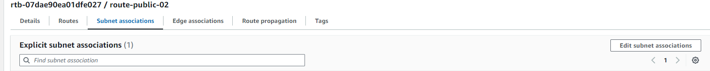

1. Select required subnet and click on save associations . (for route public-02 select public-subnet-02)

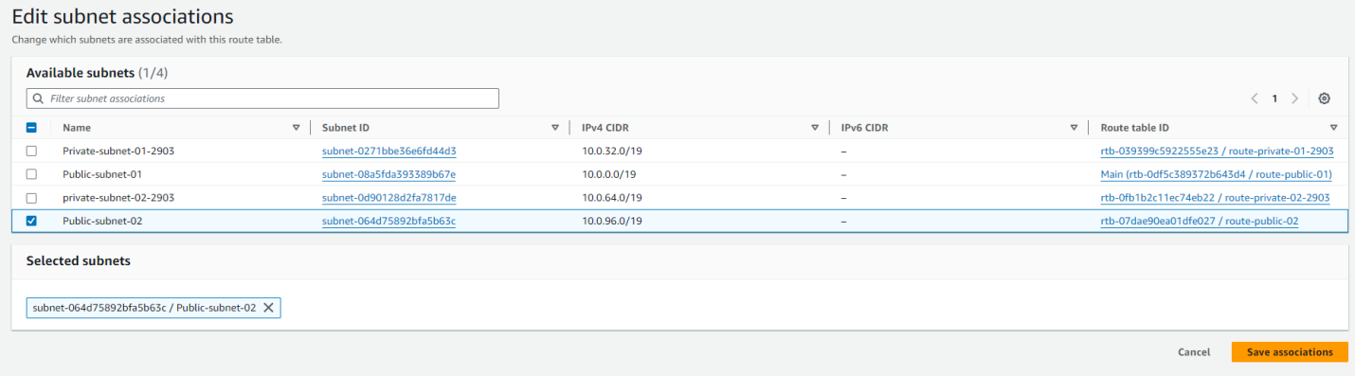

I

1. Create internet gateway – attach to VPC and nat gateway

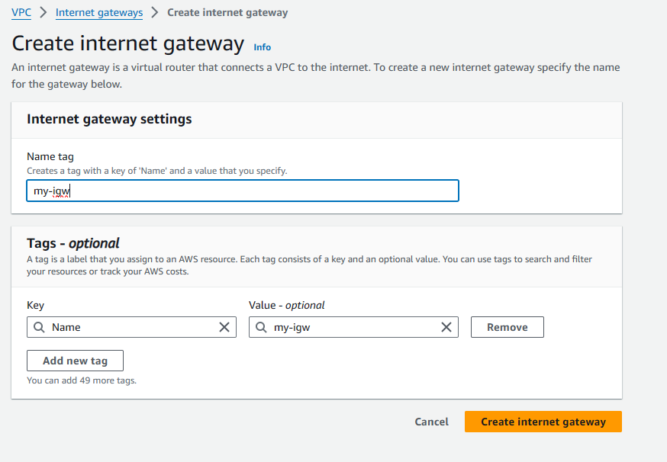

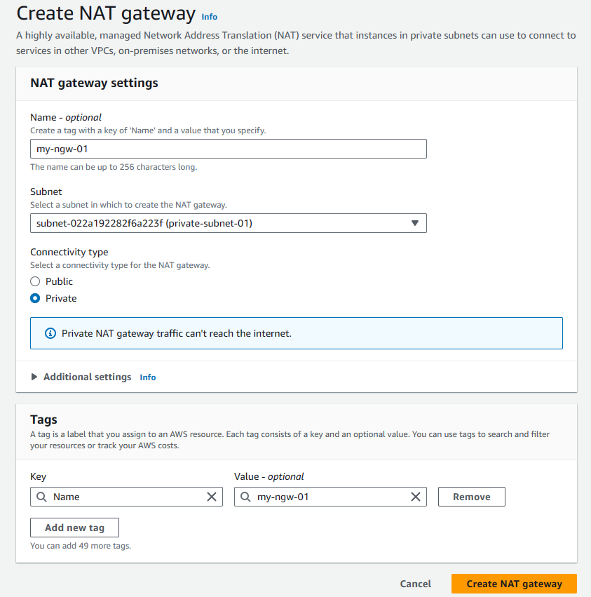

1. Connect public route tables to internet gateway and private route tables to nat gateway

Right Click on route tables -> edit routes

Give destination as ‘0.0.0.0/0’ and select the created internet gateway

Similarly to NAT gateway

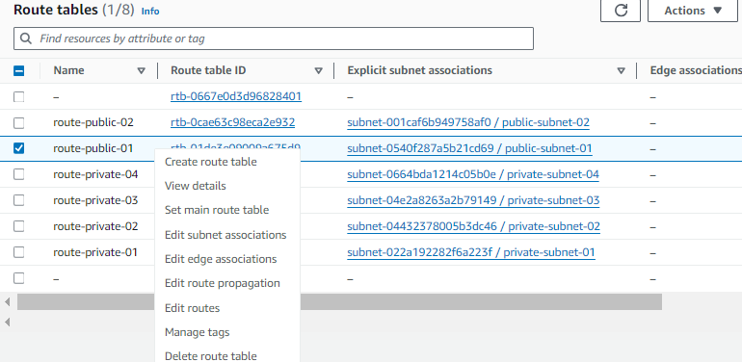

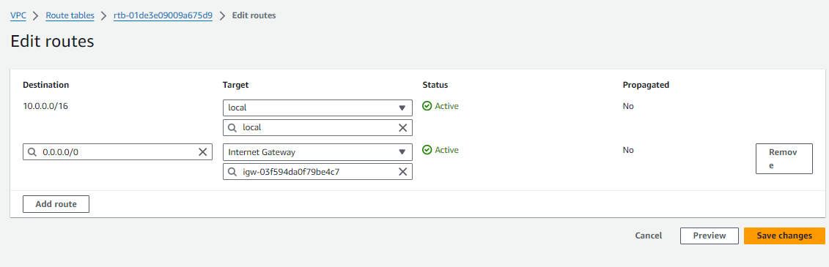

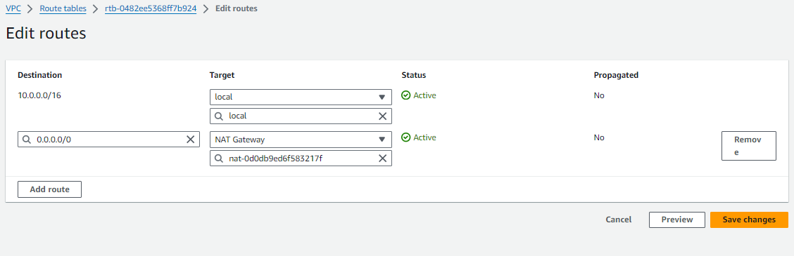

1. On subnets:

Click on subnets -> edit subnet settings-> enable auto-assign IPV4 address check box and save it

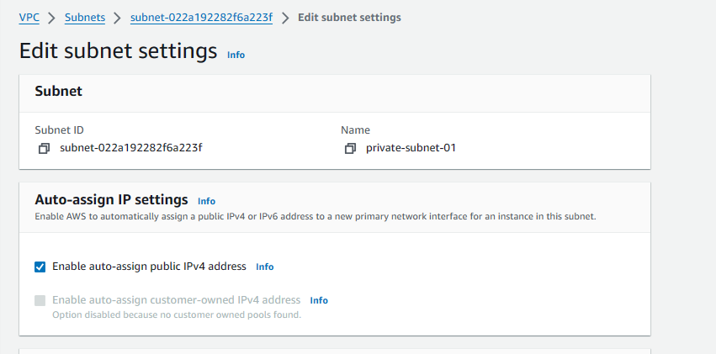

1. This the VPC resource map:

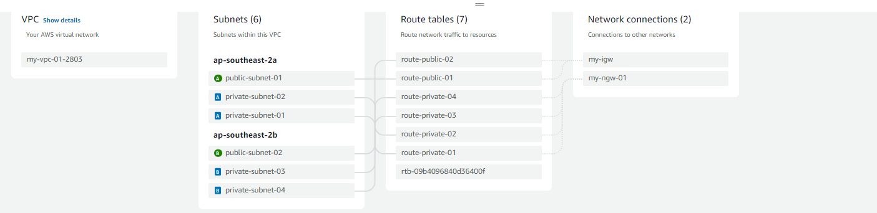

1. Create a launch template

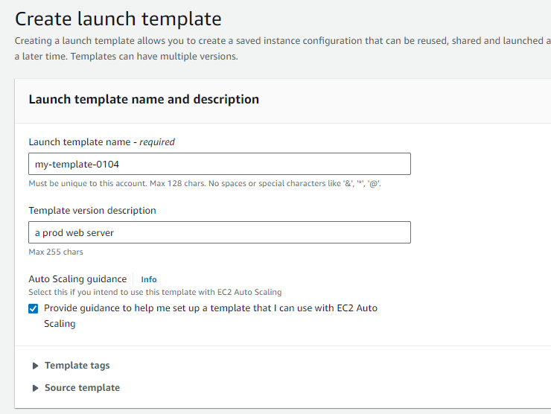

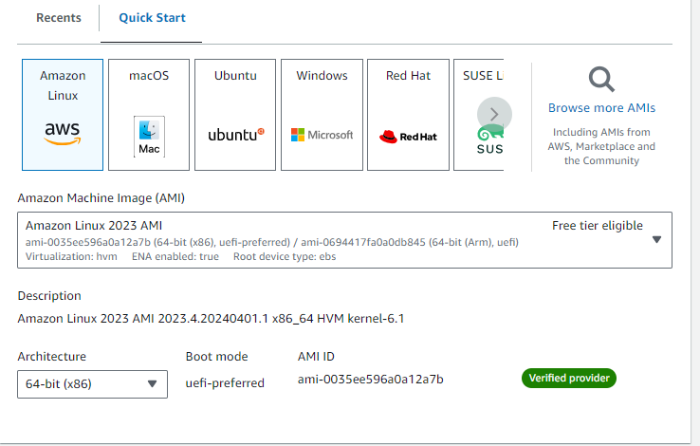

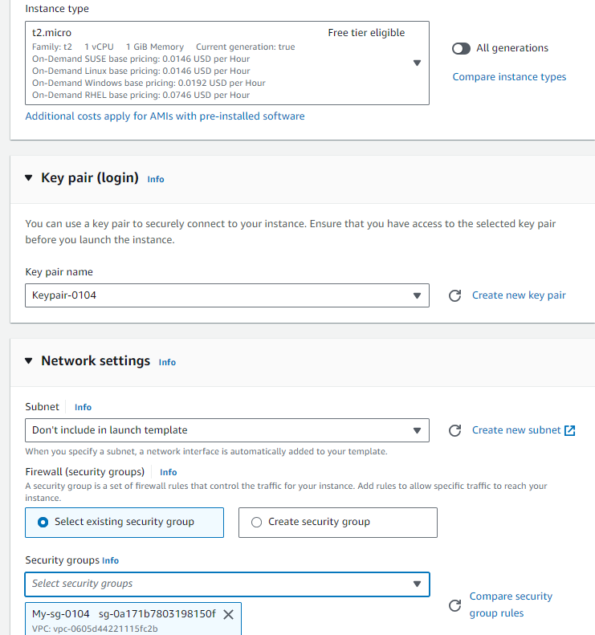



1. Create auto scaling group

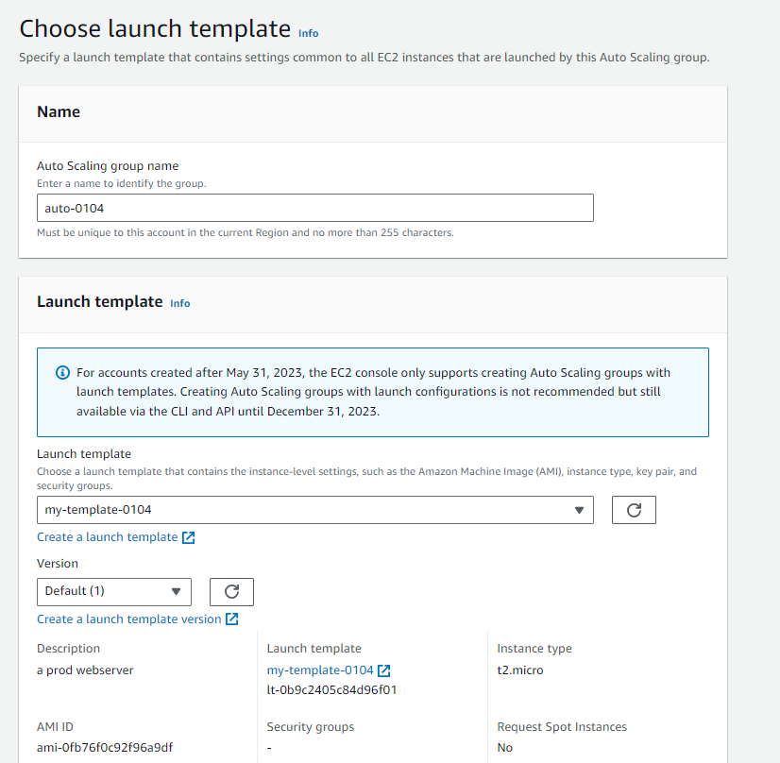

In network choose public subnets as we are doing for public subnets

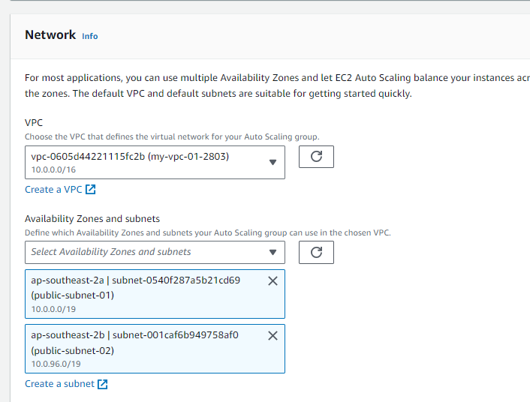

1. Select internet facing – as we have provided public subnets

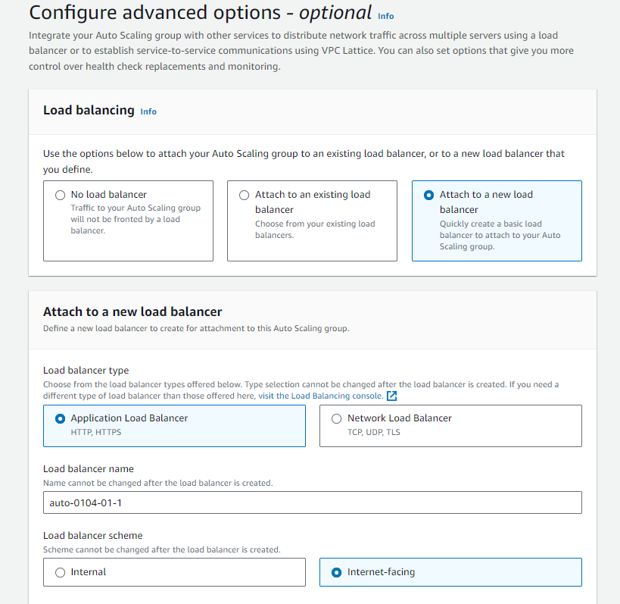

1. Select health grace period as 30 seconds

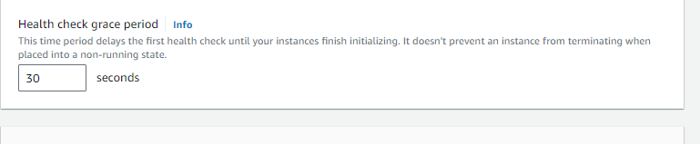

1. Select create a target group . after all options are filled . click on next

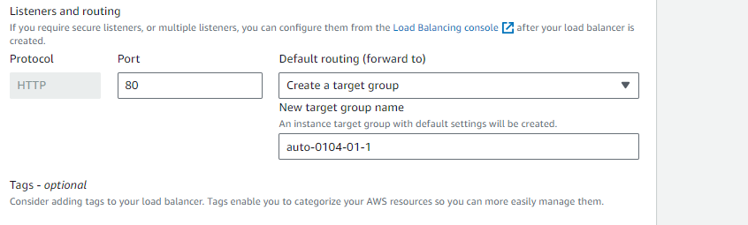

1. Click on next -> next -> click on create auto scaling group
2. 2 public instances will be created

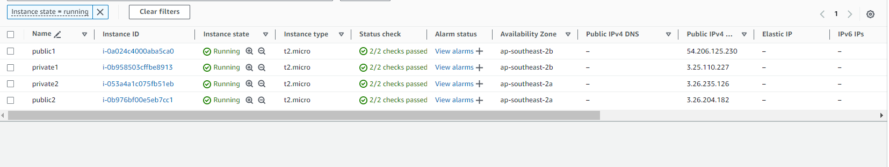

1. 2 public instances will be launched.

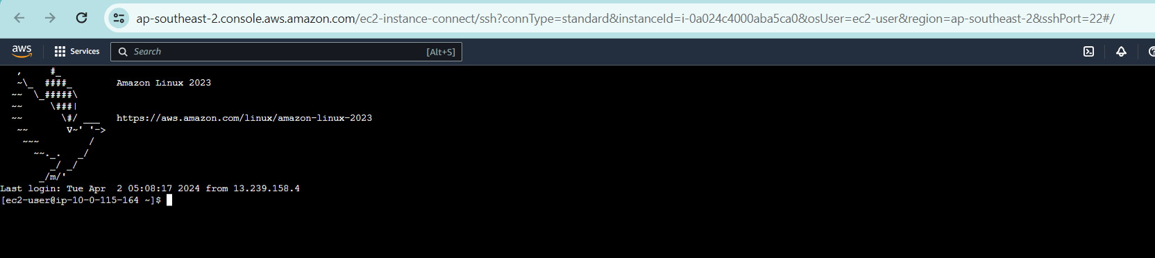

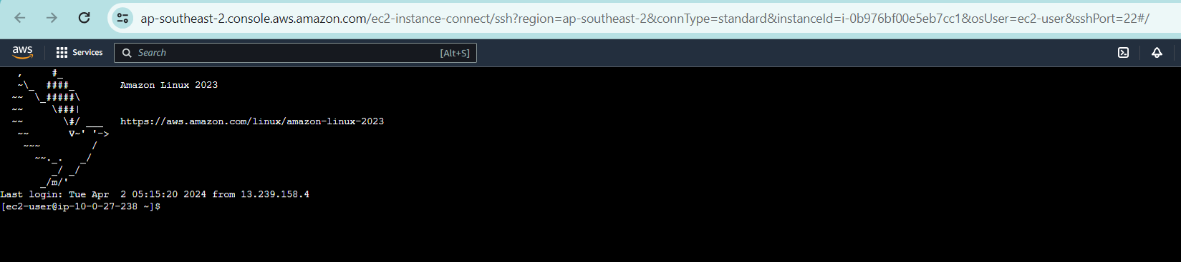

1. Create alunch template for private subnets in 2nd tier do for autoscaling for private subnets. Here we give load balancer scheme as internal

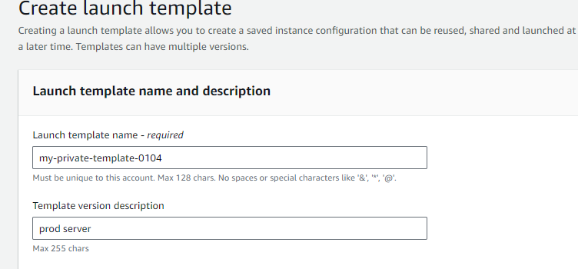

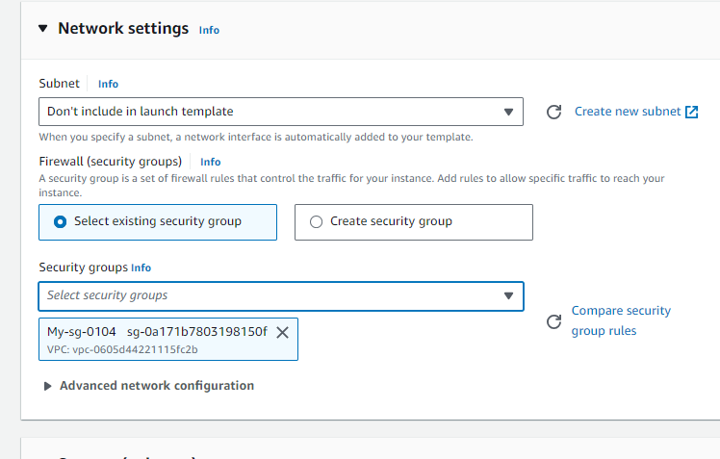­

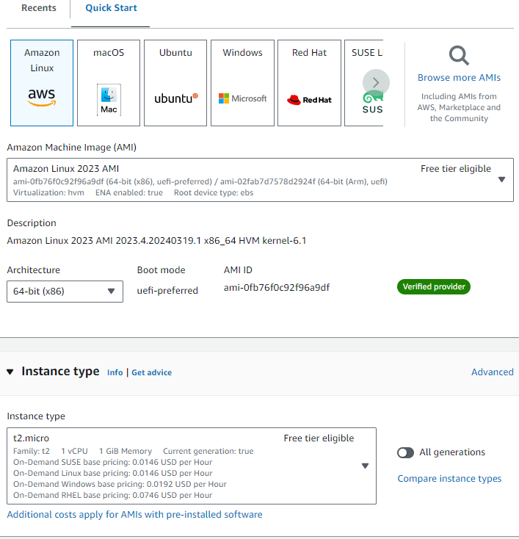

To connect to private instance 1:

Private instance must be launched through public instance

In Vi file give the data of keypair.pem file and save it

In ssh command “10.0.154.126” give private address of private subnet 1

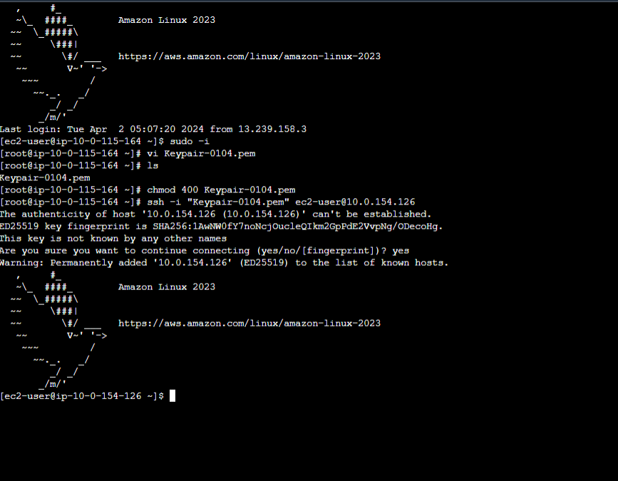

Launching another Private instance

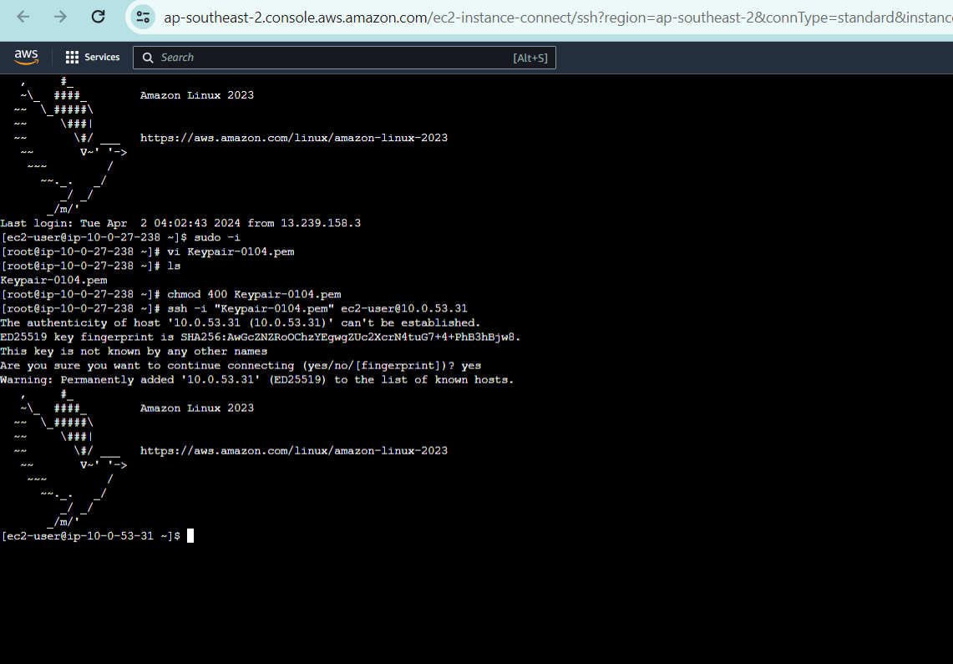

3rd part RDS:

Click on databases-> click on create database

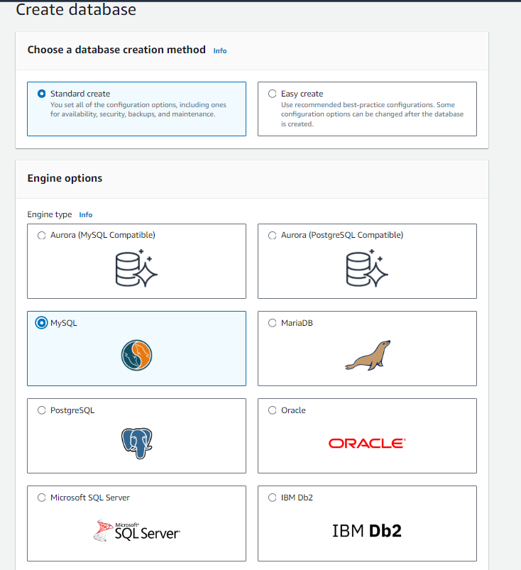

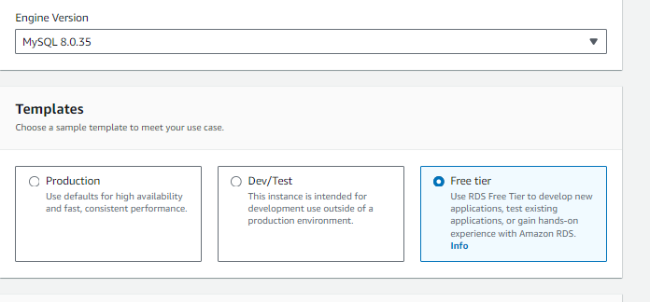

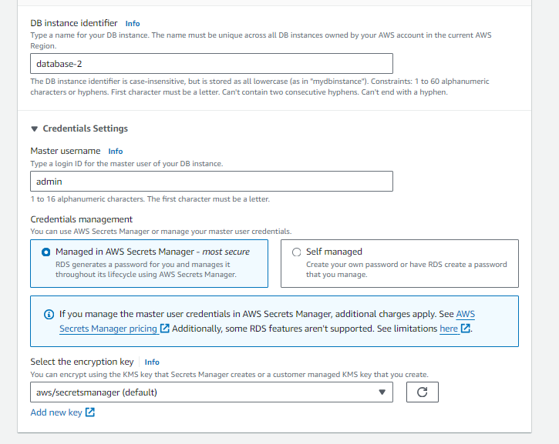

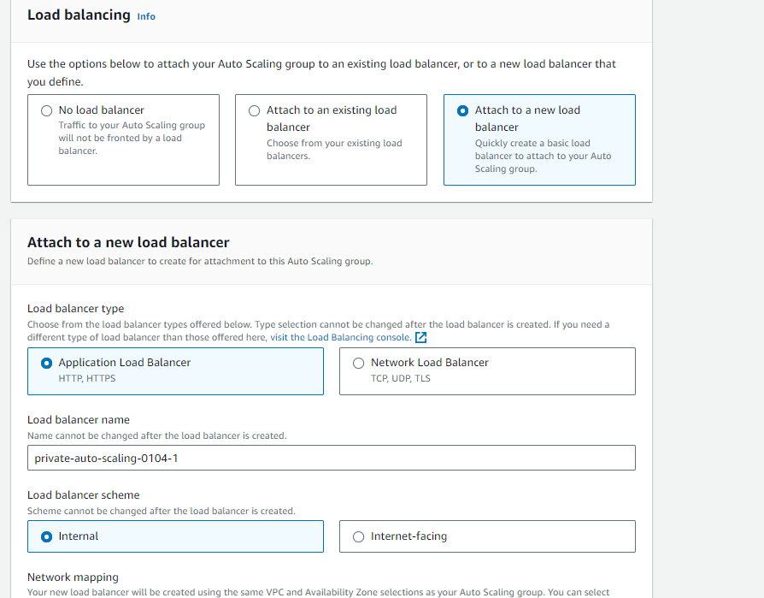

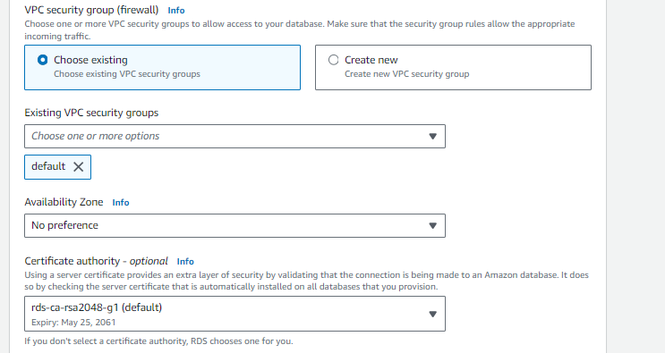

Create subnet group and database

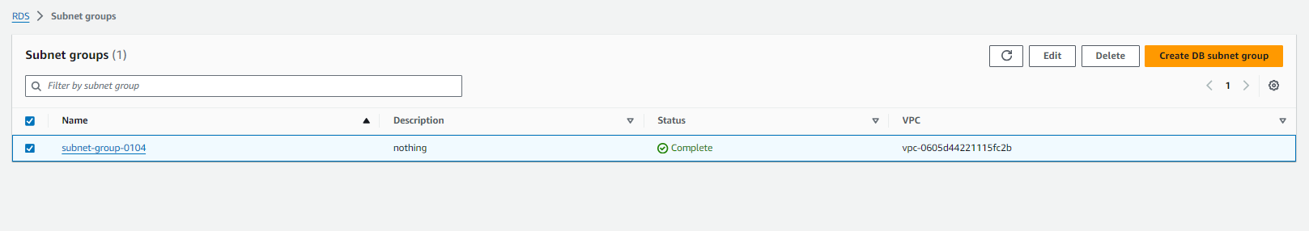

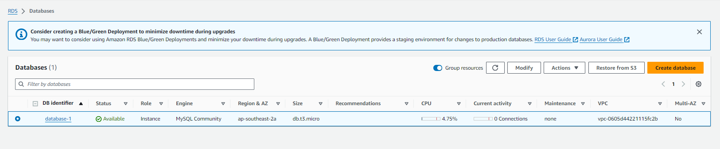

Delete the snapshot:

